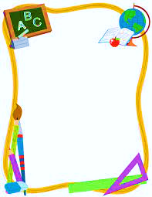

**Second Grade Supply List**

**Belair K-8 School**

**\*\*\*\*Please label your child’s name on ALL supplies.\*\*\*\***

**2 packages of pencil eraser tops**

**2 boxes of 24 pack Crayola Crayons**

**1 pack of colored pencils (24 count)**

**1 plastic pencil pouch ( no boxes please0**

**2 boxes of #2 pencils (24 count)**

**2 folders with pockets**

**2 packs of glue sticks (4 count)**

**2 pairs of headphones**

**2 composition notebooks**

**2 packs of dry erase markers**

**2 boxes of Kleenex**

**1 large bottle of hand sanitizer**

**1 pack of copy paper**

**1 Bookbag**